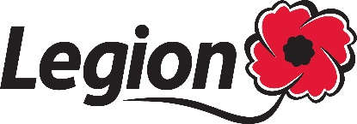

Images and words - Release Form

I _________________________________ (PRINT NAME) do hereby permit the Royal Canadian Legion (the Legion) to use, in perpetuity throughout the world, without restriction or remuneration, any of my images and words (photographs, video, written and verbal statements, and any other “materials”) accompanied, when applicable, by my name, job title and/or place of residence in any print, electronic and digital media communications used to publicize and promote the work of the Legion.
I understand and agree that all editorial decisions on the use of these materials are solely at the Legion’s discretion and may be subject to change. I also understand that the Legion is making no commitment to use any or all of such materials. I understand that should I withdraw my consent at a later date, the Legion will make all reasonable efforts to discontinue the use of my materials but that their presence in the public domain may make their complete removal impossible.
This release supersedes any previous agreements, discussions or undertakings with respect to the subject matter.
I am 18 years or older and fully understand the terms of my consent to the above.

GUARDIAN’S CONSENT:
I am the legal guardian of _____________________ (CHILD’S NAME) and on his/her behalf, I agree to all of the above.

______________________________
Signature

_______________________________
Date (M/D/Y)

_______________________________
Place of employment and job title (if applicable)

_______________________________
Phone number

_______________________________
Email

